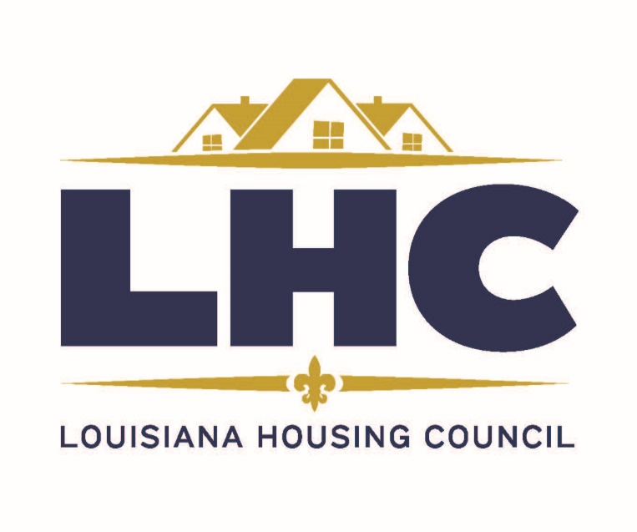
2019 May Legislative Conference
New Faces, New Places, New Ideas

May 21-24, 2019
Hilton Baton Rouge Capitol Center
201 Lafayette St. Baton Rouge, La. 70801

The Louisiana Housing Council will hold its Annual Legislative Conference, Awards Ceremony, Scholarship Presentations, & Annual Business Meeting at the Hilton Baton Rouge Capitol Center located at 201 Lafayette St. Baton Rouge, LA on May 21- 24, 2019.
Some committee meetings will be held on Tuesday, May 21, 2019, beginning at 2:00 pm. Other committee meetings will begin on Wednesday, May 22, 2019, at 9:00 am. The first time attendees’ reception will be held from 11:00 am – 11:30 am immediately followed by the scholarship recipients’ reception held from 11:30 am – Noon. All are invited to visit with the Scholarship Recipients during this time. Our Luncheon will begin at Noon with the Scholarship Presentations and a Legislative Committee Report.
The Seafood Fest will be held at the Capitol Park Event Center at 5:30 pm on Wednesday, May 22, 2019. This event gives us an opportunity to meet with our legislators to discuss pending legislation and to thank them for their assistance.
This year, the awards presentation will be held on Thursday evening during the Presidential Banquet. Following the awards presentation, LHC invites you to a night of entertainment with music provided by Todd Ortego. After five/Cocktail/Sunday best attire is encouraged.

Hotel Information:
To ensure you have hotel accommodations, please make your reservations directly with The Hilton Baton Rouge Capitol Center by calling 1-800-955-6962 and provide the code (LHC) or ask for the “LA Housing Council” group. The hotel is offering a rate of $148.00, plus tax, for single or double occupancy for room reservations made under the Louisiana Housing Council room block. Do not delay. The cut-off date for this special room rate is Monday, April 29, 2019.
Below are the Tentative Agenda Topics:
-Procurement Training: Audrey Plessy, HANO
-Fair Housing – Pet Policy / Service Animal: Brandon Decuir, Attorney, DeCuir, Clark, & Adams, L.L.P.
-Commissioners Continuing Education Class: Katie Anderson, NAHRO
-HOTMA Topics – HUD New Orleans
*Project Based Vouchers (PBV) session
*Operating Subsidy session
*Repositioning will include information regarding Consolidation, the Rental Assistance Demonstration (RAD) and Section 18
*Other Topics will follow on the Agenda at a later date

